**Train With Hydrogen Power**

Two [Alstom](https://www.alstom.com/) **hydrogen-powered** trains have underway marketable traveller facilities in Germany’s [Lower Saxony](https://en.wikipedia.org/wiki/Lower_Saxony) region.

[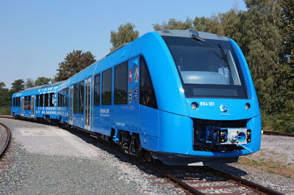](https://4.bp.blogspot.com/-jifIvsIhcqA/W8qZ9ZFB6rI/AAAAAAAAASs/7_M6zujZA-8_fi7Gavnj0G2WBz4GGB8ygCLcBGAs/s1600/IMG_5032_iLint_A.0.jpg)

[Dr Bernd Althusmann](https://en.wikipedia.org/wiki/Bernd_Althusmann) said:

The emission-free drive technology of the Coradia iLint provides a climate-friendly alternative to conventional diesel trains, particularly on non-electrified lines

[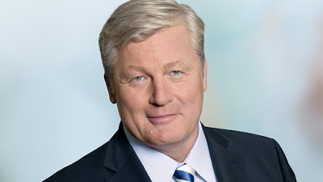](https://1.bp.blogspot.com/-P20LZPs_8mU/W8qaYXe41UI/AAAAAAAAAS0/l_Q1cqWj_j051GYqwXKKkJ2ob8RfPqNVwCLcBGAs/s1600/althusmann-nds-780_0.jpg)

The two **Coradia iLint** will run on the [EisenbahnenundVerkehrsbetriebe Elbe-Weser](https://en.wikipedia.org/wiki/Eisenbahnen_und_Verkehrsbetriebe_Elbe-Weser)’s (EVB) Elbe-Weser network. The trains were industrialized in [Salzgitter](https://en.wikipedia.org/wiki/Salzgitter), **Germany**

Proficient of travelling at up to **140km/h** the two Alstom Coradia iLint trains will assist a **100km** route running between **Cuxhaven, Bremerhaven, Bremervörde and Buxtehude**. The line was earlier assisted by **diesel** units functioned by Eisenbahnen und Verkehrsbetriebe Elbe-Weser (EVB).

In a isolated development, [Bombardier](http://www.transportation.bombardier.com/en/home.html) welcomed [Ferlemann](https://de.wikipedia.org/wiki/Enak_Ferlemann) and other invitees on the initial journey of the Talent 3 **electro-hybrid train** at the company’s Hennigsdorf site on **September 12, 2018.**

[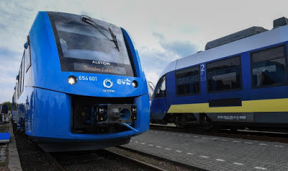](https://2.bp.blogspot.com/-2NiBW-an6Tw/W8qarVMFN2I/AAAAAAAAAS8/oMY5rUCaR0AmAKlj03m8PP2IKPsl4cs5gCLcBGAs/s1600/Worlds-first-hydrogen-fuel-cell-passenger-train-begins-service-in-Germany.jpg)

The occasion was renowned by **Alstom**, one of Europe’s major railway industrialists; the Minister of Economy and Transport of Lower Saxony; the Federal Ministry of Transport and the transport consultants of [Landesnahverkehrsgesellschaft Niedersachsen](https://www.lnvg.de/) (LNVG); and Eisenbahnen und

Verkehrsbetriebe Elbe-Weser (EVB) in Bremervörde on **September 16.**

Dr Bernd Althusmann, Lower Saxony’s Minister of Economy and Transport, whose branch has

supported **LNVG’**s buying of another **14 hydrogen trains** with more than **€81 million**, is overwhelmed. He explained:

With the test operation starting today, Lower Saxony is performing real pioneering work in local transport in cooperation with Alstom and EVB. The emission-free drive technology of the Coradia iLint provides a climate-friendly alternative to conventional diesel trains, particularly on non-electrified lines

[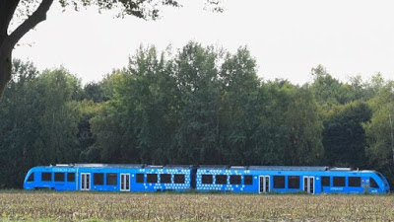](https://4.bp.blogspot.com/-E4LZ7Cr3uZY/W8qa_QRFqII/AAAAAAAAATE/FfGoCkaLRf0rHnMOCDT5-sPSTpf1BfXywCEwYBhgL/s1600/8ab7d05c0295f3d456650e6d13fd44ad.jpg)

**Stefan Schrank**,  the project’s supervisor at **Alstom**, said:

Sure, buying a hydrogen train is somewhat more expensive than a diesel train, but it is cheaper to run